Supplementary Figures

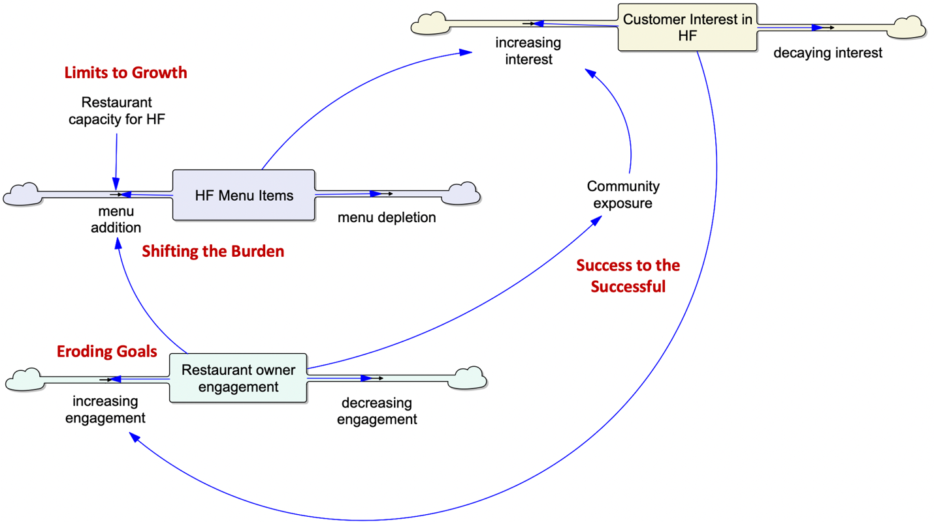
Figure S1. Stock-and-flow representation of the FRESH healthy restaurant intervention.
The model represents the implementation and sustainability dynamics of healthy food (HF) adoption in restaurants using three principal stocks: restaurant owner engagement, HF menu items offered by restaurants, and customer interest in healthy foods. Owner engagement increases the rate at which restaurants introduce HF menu items (menu addition), while the presence of HF offerings increases customer interest through both direct exposure to menu items and indirect exposure through community engagement and promotion. Customer interest can in turn reinforce restaurant owner engagement through demand signals, forming the primary reinforcing feedback loop linking restaurant adoption and customer demand. While an intervention team drives many of the positive flows into the stocks, as described in the abstract, there are several balancing processes that counteract the reinforcing loop, including engagement decay, menu depletion due to operational constraints, and declining customer sales and interest.
Several pathways and components in the stock-and-flow diagram correspond to classic system archetypes. Limits to Growth arises when reinforcing growth in HF adoption is constrained by restaurant capacity. Shifting the Burden reflects the intervention’s emphasis on strengthening restaurant capacity for offering HF rather than relying primarily on short-term demand incentives. Eroding Goals appears as a gradual decline in engagement and is mitigated through regular visits by interventionalists and continued technical assistance. Success to the Successful arises when increased visibility of HF adoption among restaurants through social media promotion, community engagement, and dashboards encourages further adoption.
The reinforcing pathway linking restaurant adoption and customer demand represents the mechanism through which the intervention can transition from implementation-driven change to self-sustaining healthy food adoption.
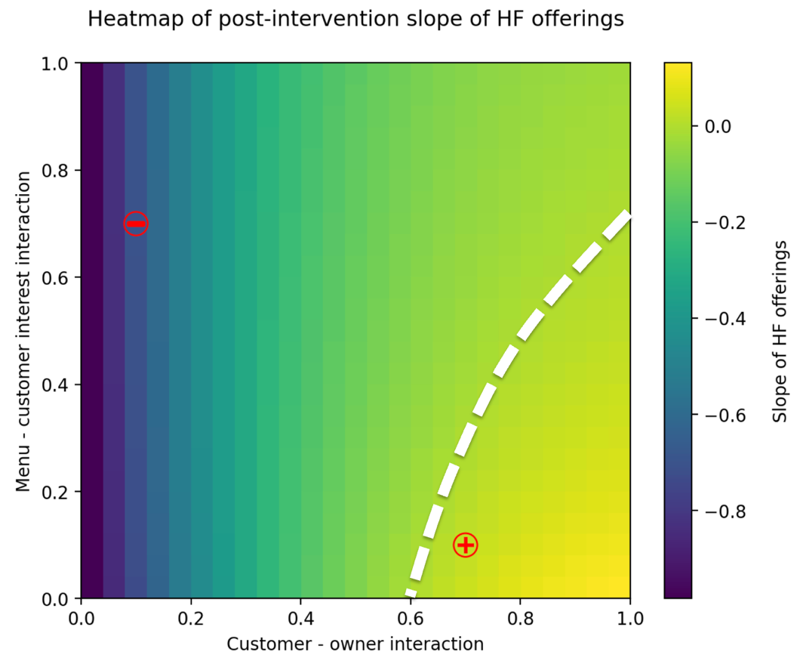
Figure S2. Tipping behavior in the sustainability phase of the FRESH intervention model.
The heatmap shows the trends of HF menu adoption with respect to two key parameters: the responsiveness of restaurant owners to customer demand signals (Customer – owner interaction) and the responsiveness of customers to HF menu offerings (Menu – customer interest interaction). Each point represents the slope of HF menu adoption during the sustainability (post-intervention) phase.
Regions with positive HF slope: For every point in this region, the number of HF menu items increases after the end of the intervention. Hence, these points correspond to a self-sustaining adoption regime
Regions with negative HF slope: For every point in this region, the number of HF menu items decline after the end of the intervention. Hence, these points correspond to reduced adoption.
Boundary between positive and negative HF slope: The points along the dashed line correspond to tipping points that separate these regions. This is where reinforcing feedback between restaurants and customers becomes sufficiently strong to overcome balancing processes such as engagement decay, menu depletion, and declining customer attention.
The red (-) and (+) markers indicate parameter combinations corresponding to decaying and sustaining HF menu offerings, respectively. The corresponding system trajectories are shown in Figure S3.
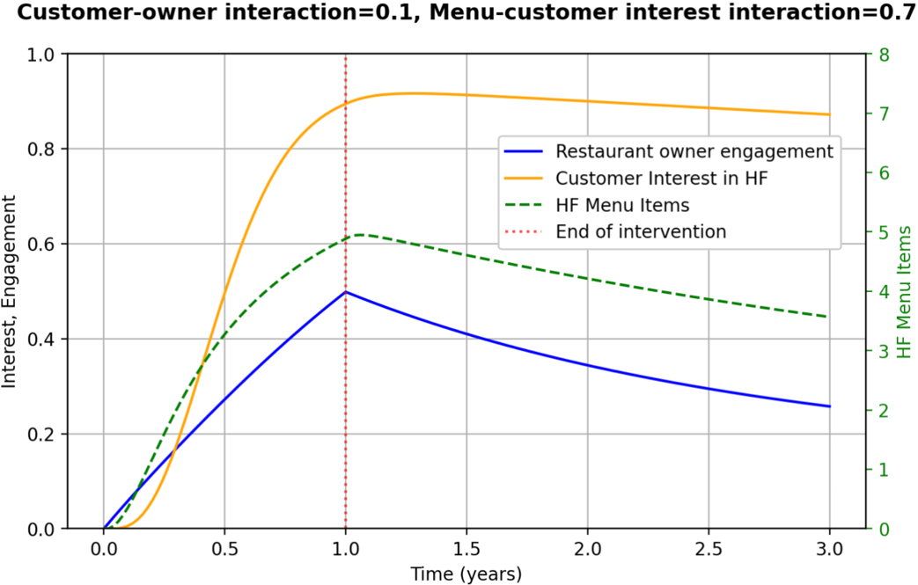

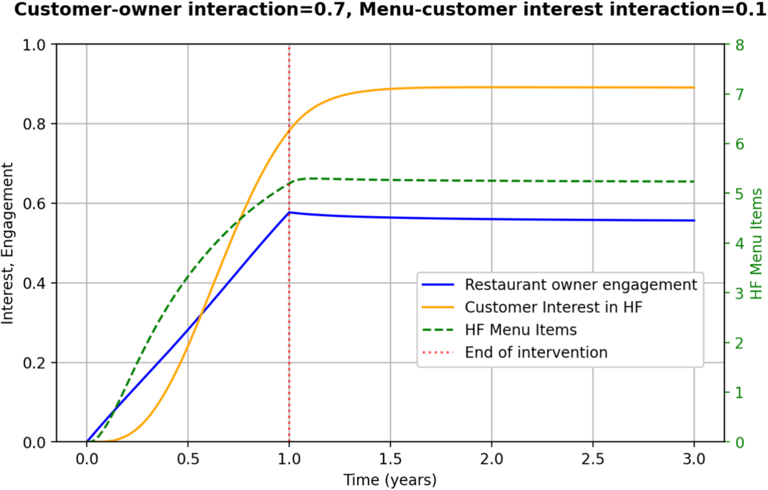
Figure S3. System behavior during the implementation and post-intervention phases.
Time trajectories of restaurant owner engagement, customer interest in HF, and the number of HF menu items (left axis) under parameter settings shown at the top of each plot.
Top plot illustrating decaying intervention effects: During the implementation phase, intervention activities increase restaurant engagement and HF offerings. After the intervention ends, the system gradually returns toward its pre-intervention equilibrium with decreasing number of HF offerings.
Bottom plot illustrating sustained intervention effects: By increasing the responsiveness of restaurant owners to customer interest (C customer owner = 0.7) HF offerings are sustained post-intervention. It is noted that sustainment is predicted even while the responsiveness of customers to HF menu offerings was reduced (C menu interest = 0.1), highlighting the importance of the lower segment of the reinforcing feedback loop between customers and restaurant owners in Figure S1.

